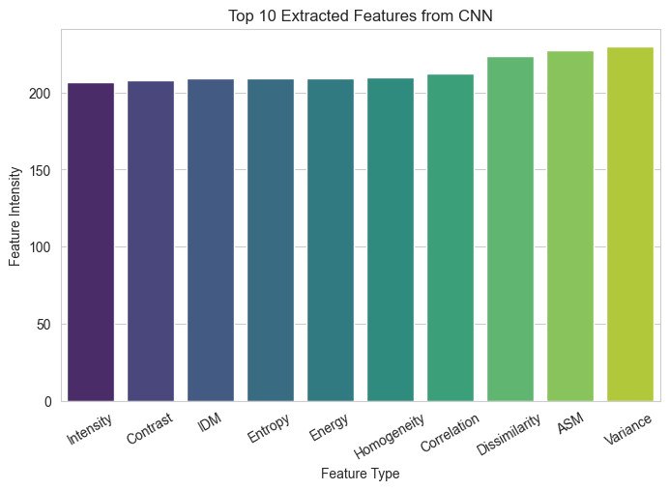

**Figure 7. Feature Extracted from CNN**